**Twixt!**

By: Steven Speicher

2007

Board Description:

The game of Twixt is made up of a 24x24 pegged game board. Each red and blue has a set of pegs and connectors to be placed on the board.

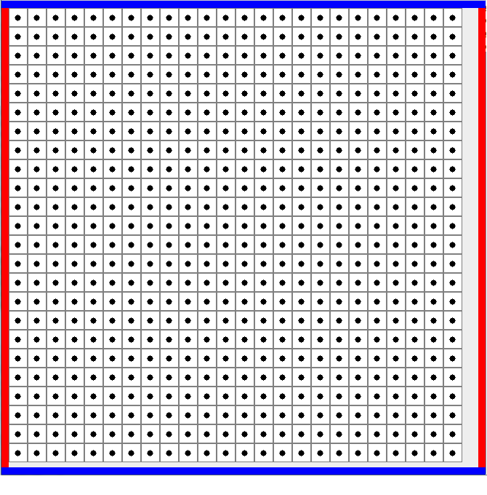

Who Goes First:

Red always gets to play first.

How To Play:

The players take turns placing pegs of their respective colors anywhere on the board, except the opponent’s row or column (see Figure 1), one peg per turn. After placing a peg, the pegs are connected to one or more pairs of pegs on the board which are all your own color. The connectors can only go between two pegs a knight's move away from each other (see Figure 2), and cannot cross another connector (see Figure 3). They block other connectors, most importantly, the opponent's.

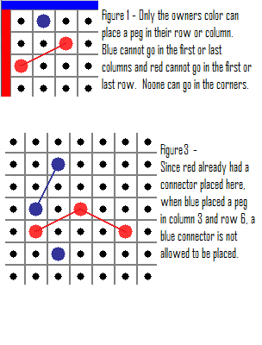 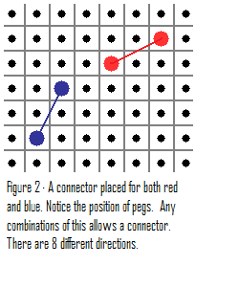

How To Win:

One player wins when they make a full path from their first row or column to their last row or column by any means (see Figure 4).

